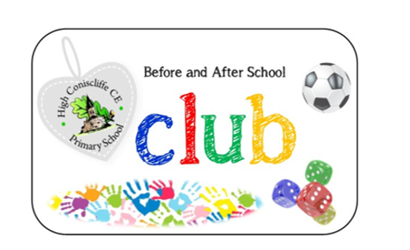
Club is run by High Coniscliffe School staff and is open in the mornings from 7.30am – 9.00am Monday to Friday and the afternoon sessions are from 3.15pm until 5.30pm. The children are offered a full range of activities using the school resources and site. We can even assist with homework!
Booking requirements are confirmed by completing a monthly booking form which is available from the school office in advance, however we understand childcare needs to be arranged last minute sometimes and so we are very flexible but please let us know your arrangement as soon as possible as this would help us plan staffing and activities.
Please ensure you collect your child/ren before or at 5.30pm as Club and the School closes then. (A late fee of £5.00 will be charged).
An invoice is raised at the end of each month, this can be paid via bank transfer (account information will be on your invoice) or the Government childcare voucher schemes.
Please see prices below:
BEFORE SCHOOL CLUB (includes breakfast) 7.30am – 8.30am £4.40
FREE BREAKFAST CLUB 8.30am-9.00am Free
AFTER SCHOOL CLUB 3.15pm-5.30pm £7.50
Please do not hesitate to contact school if you have any queries on 01325 374412 or office@highconiscliffe.org.uk


